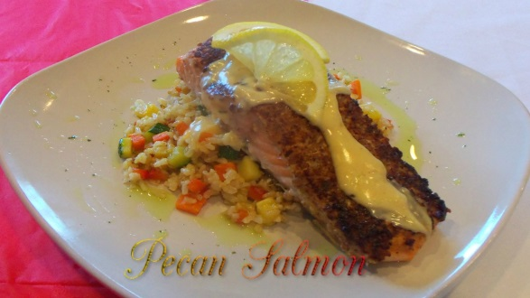

- 9 oz. Salmon
- 1 bag of Success Brown Rice
- 1 Onion, diced
- 1 Carrot, diced
- 1 Red Pepper, diced
- 1 Zucchini, diced
- 1 Squash, diced
- 4 oz. of Pecans
- 1 cup of Heavy Cream
- ½ TSP of smoked paprika
- 1 TSP of Honey
- 1 TSP on lemon juice
- 1 cup Gluten free flour
- 1 Egg
- ½ TSP water
- Salt & Pepper to taste

Directions:
- Chop Pecans in a food processor or blender, while pecans is chopping prepare dredging process beat egg and water together on a plate place flour in a plate. Lay pecans on cutting board, season Salmon with salt & pepper, put salmon face down in flour, place salmon in egg wash, place Salmon face down on top of pecans, press down until salmon is coated. Put 1 oz. of oil in a medium heat pan; sear Salmon for 2 mins or until golden brown flip over place in a 350 ° oven cook for 10 mins.
- Place rice in boiling water for 5 mins. Sauté veggies of 3 mins add rice toss together salt & pepper to taste.
- To make sauce: In a sauce pan add cream, honey & paprika simmer for 3-4 mins until reduce add lemon juice.

